REACT COMPONENTS (CARD AND BUTTON)

NAME : SRAVANI GANGA KAMIREDDY
EMAIL : 20t91a0536@gmail.com
PHONE NO : 8297418679
ROLL NO : 20T91A0536 (CSE)
COLLEGE NAME : GIET Engineering College

CARD COMPONENT:

SOURCE CODE:

CardComponent.jsx :

import React from 'react'

export default function Home({img, title, description}) {
return (
<div className='shadow-xl border-blue-500/30 border-2 m-11 rounded w-64 bg-white'>
<div className='h-48 '>
<img src={img} alt="placeholder" />
</div>
<div className='p-4'>
<h1 className='text-black font-bold '>{title}</h1>
<p className='text-black'>{description}</p>
</div>
</div>
)
}

Page.js:

"use client"
import CardComponent from "./components/CardComponent";
import { useState } from "react";
export default function Home(){

return (
<div>
<CardComponent
img="https://www.euroschoolindia.com/wp-content/uploads/2023/10/importance-of-eating-a-variety-of-fruits-for-kids-health-jpg.webp"
title="fruits"
description= "A fruit is the ripened ovary of a flowering plant that contains seeds. Fruits can be fleshy or dry, and are usually sweet or sour. They can be found in three main anatomical categories: aggregate fruits, multiple fruits, and simple fruits."/>

</div>
)
}

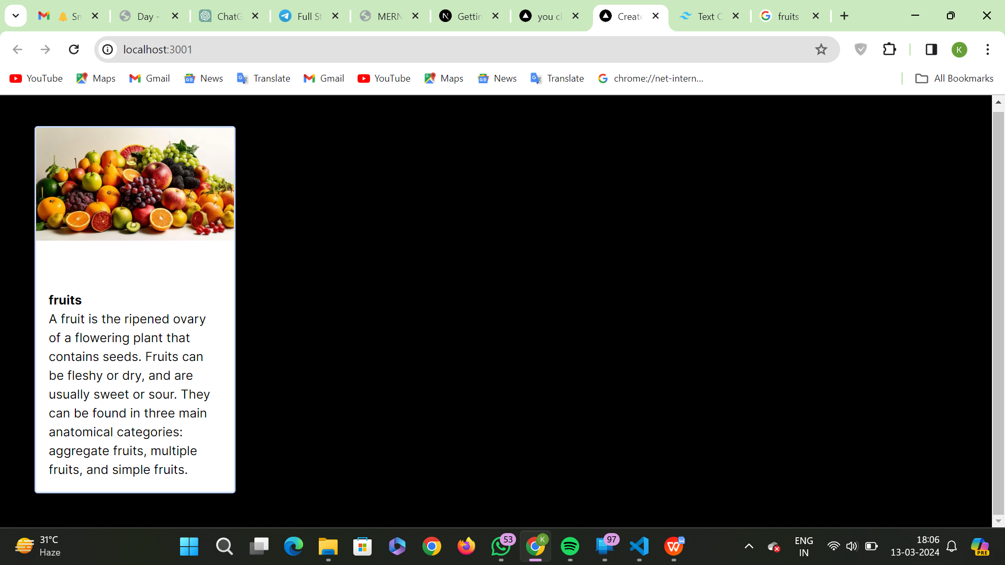
Output :
BUTTON COMPONENT:

SOURCE CODE:

Page.js :

import React from 'react'
import Button from './components/Button'

function page() {
return (
<div >
<Button >Hello</Button>
<Button >World</Button>
</div>
);
}

export default page;

Button.jsx:

import React from 'react'

function Button(props) {
const {children} = props
return (
<div>
<button className='text-black border border-white rounded m-5 bg-white '>{children}</button>
</div>
)
}
export default Button

Output:

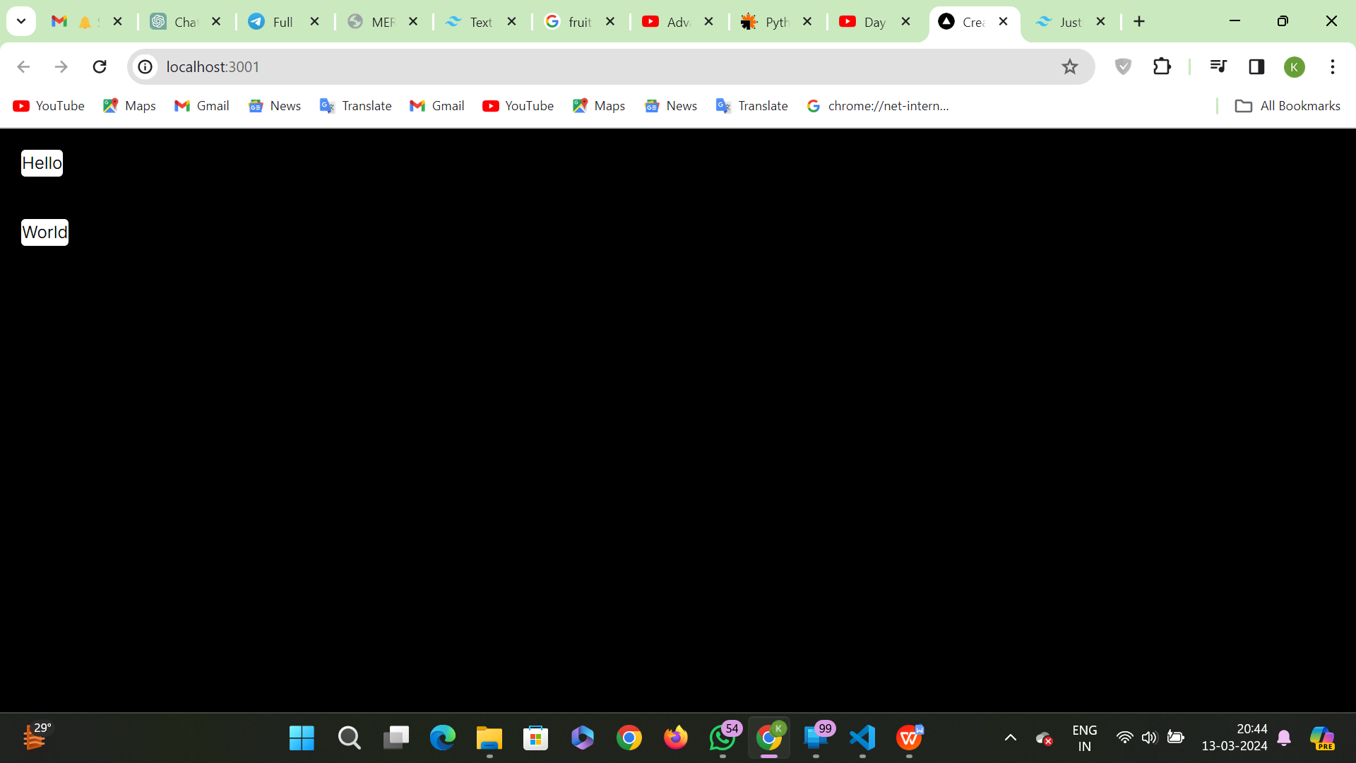

Component Integration:
Page.js:
"use client"
import CardComponent from "./components/CardComponent";
import Button from "./components/Button";
import { useState } from "react";
export default function Home(){
const [label, setlabel] =useState("continue");
const clickme = ()=> {
alert("Hello");
};
return (
<div>
<CardComponent
img="https://www.euroschoolindia.com/wp-content/uploads/2023/10/importance-of-eating-a-variety-of-fruits-for-kids-health-jpg.webp"
title="fruits"
description= "A fruit is the ripened ovary of a flowering plant that contains seeds. Fruits can be fleshy or dry, and are usually sweet or sour. They can be found in three main anatomical categories: aggregate fruits, multiple fruits, and simple fruits."/>
</div>
);}
CardComponent.jsx:
import React, { Children } from 'react'

export default function Home({img, title, description}) {
return (
<div className='shadow-xl border-blue-500/30 border-2 m-11 rounded w-64 bg-white'>
<div className='h-48 '>
<img src={img} alt="placeholder" />
</div>
<div className='p-4'>
<h1 className='text-black font-bold '>{title}</h1>
<p className='text-black'>{description}</p>
<button className='text-black border bg-yellow-200 border-black rounded m-3 px-2'> button 1</button><br />
<button className='text-black border bg-yellow-200 border-black rounded m-3 px-2 '> button 2</button>
</div>
</div>
);
}

Output:

